Worksheet N°2
Name: _______________________________________________________________
Objective:
- Demostrar uso del lenguaje relacionado a funciones del lenguaje para hablar en pasado y sobre trabajos

Skills
- Aplicar
- Reconocer

Instructions:
a) Use a blue or black pen, no corrections, readable handwriting
b) Do not use translator, use an online dictionary https://www.wordreference.com/
c) Use online conjugator https://www.wordhippo.com/

Part I Vocabulary
Match the correct job with the corresponding image
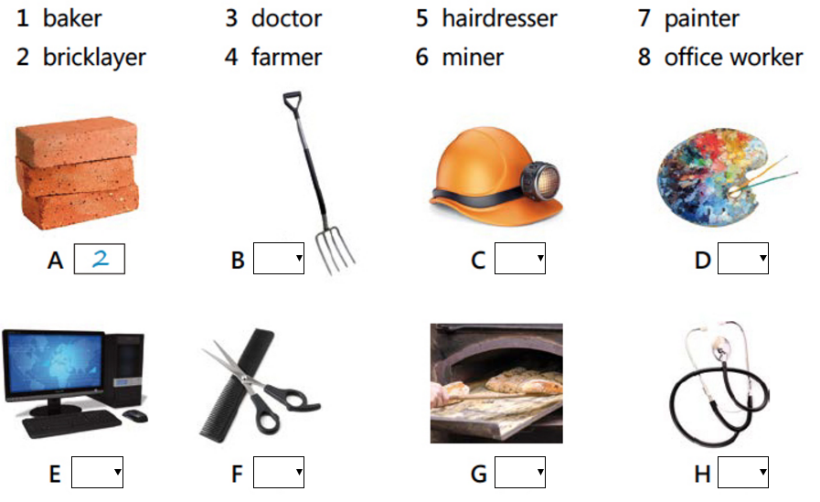

Part II Grammar
- Write the past simple form of the following verbs
Start | Started | Phone
Love |  | Worry
Copy |  | Plan
Chat |  | Clap
Regret |  | Cheer
Smile |  | Dial

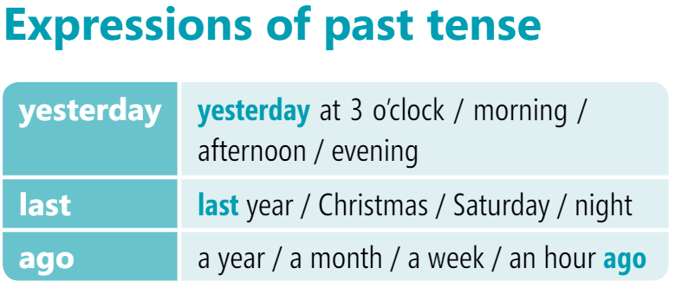

Complete the sentences with the past simple form of the verb in brackets (). UNDERLINE past expressions and translate them
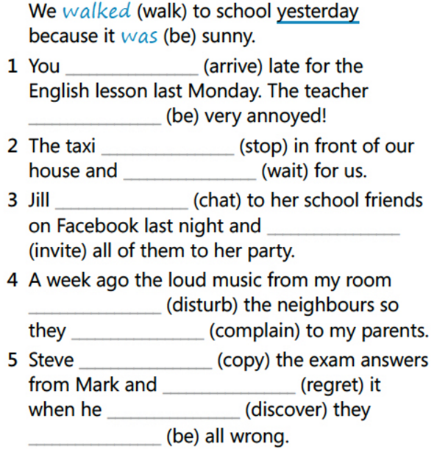

Une
Escribir
aplaudir
Arrepentirse
Animar
Marcar (teléfono)
Subrayar
Traducir

