2nd Grade: At the zoo
Worksheet 2: animals and numbers
Name: | Date:

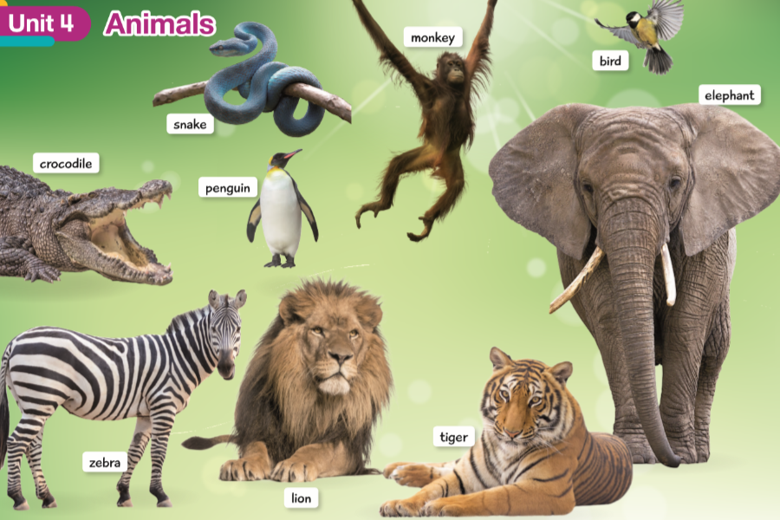
Vocabulary

- Complete with the correct name of the animals.
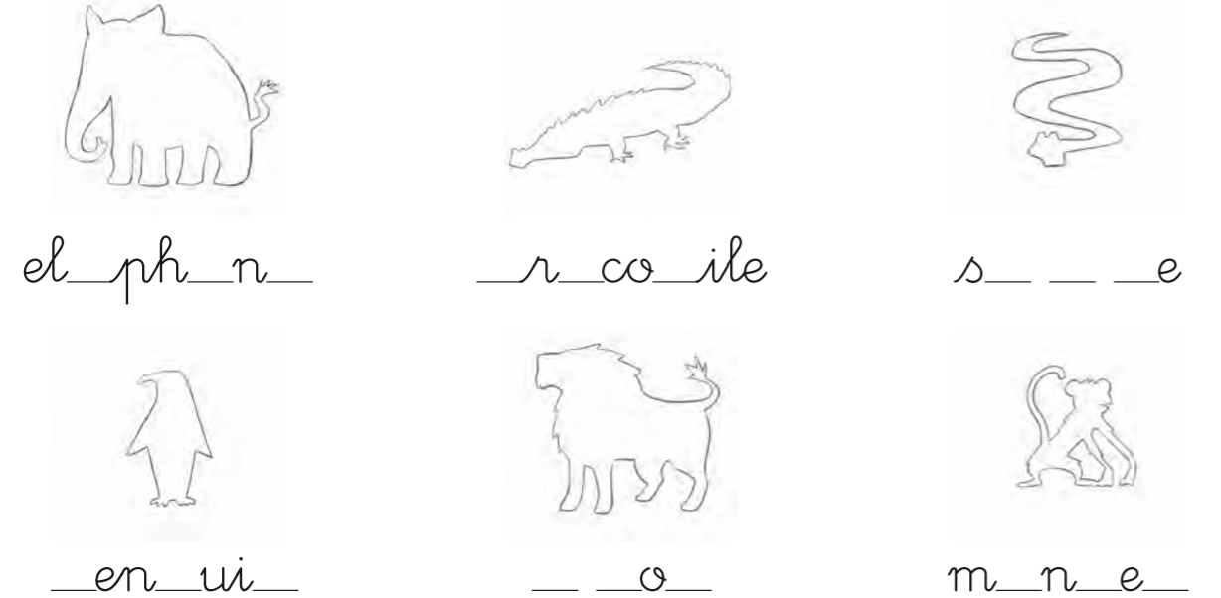

Vocabulary

- Answer the questions/ Responde las preguntas según su habilidad de cada animal.
- Can: Puede
- Can’t: No puede

