Worksheet n°1
Name: _______________________________________________________________
Objective:
- Demostrar uso del lenguaje relacionado a funciones del lenguaje para sobre acciones que comienzan en pasado y continúan en presente

Instructions:
a) Use a blue or black pen, no corrections, readable handwriting
b) Do not use translator, use an online dictionary
c) Use online conjugator https://www.wordhippo.com/
d) Use online dictionary http://wordreference.com/

Skills
- Aplicar
- Reconocer

Part I Grammar
Present perfect

The present perfect refers to:
- Actions that started in the past and impacts or continues in present.

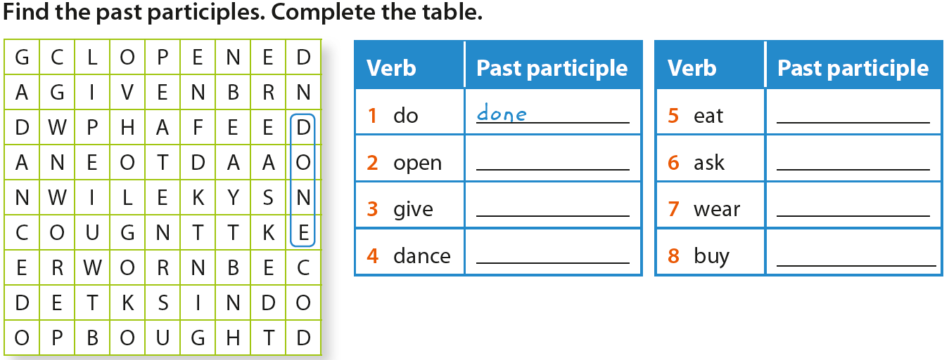
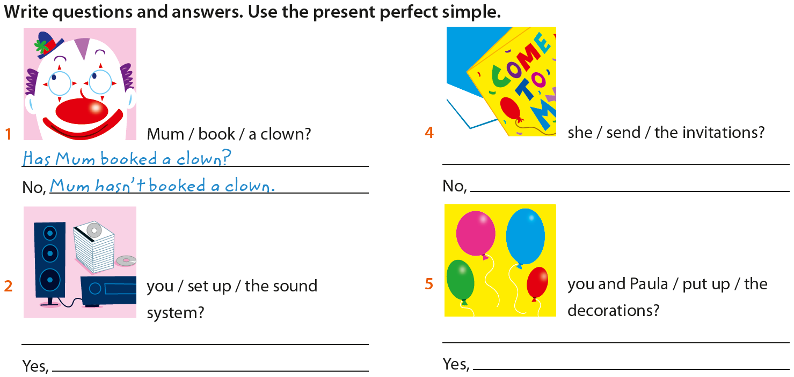
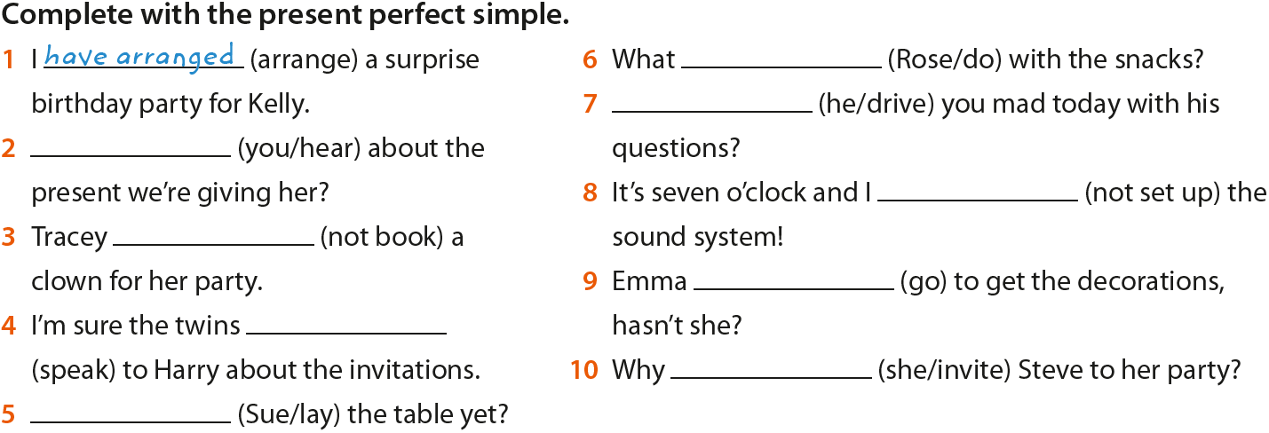
Part II Reading and listening
Global Issues

Watch the video From Syria to Germany a tale of two brothers or scan with your cellphone the qr code.
Complete the following activities

Organize the events chronollogicaly using numbers
______ War broke out in Syria
______ It is dangerous to stay in our region
______ Ali and Ahmed lived with their parents
______ They now live in a children’s home in Germany
______ They travelled to Germany

Asnwer True or False
- Ali’s dream is to go to France _____
- It took three weeks for the brothers to get from Lesbos in Greece to Germany___
- According to Ali, Germany is beautiful, safe place ______
- Ali is unhappy because he is not with his friends ______
- Ali is happy because his brother and he arrived safely at Germany_____

Glossary: Book: Reservar Twins: Gemelos Lay: colocar/poner Drive: volver Mad: loco/a
Seguro
Lugar
Llegaron

