Worksheet N°2
Name: _______________________________________________________________
Objective:
- Demostrar uso del lenguaje relacionado a funciones del lenguaje para hablar en pasado y sobre trabajos

Skills
- Aplicar
- Reconocer

Instructions:
a) Use a blue or black pen, no corrections, readable handwriting
b) Do not use translator, use an online dictionary https://www.wordreference.com/
c) Use online conjugator https://www.wordhippo.com/

Part I Vocabulary
Global Issues

Match the correct image with the corresponding global issue
1.  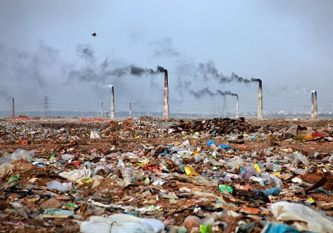 | 2.  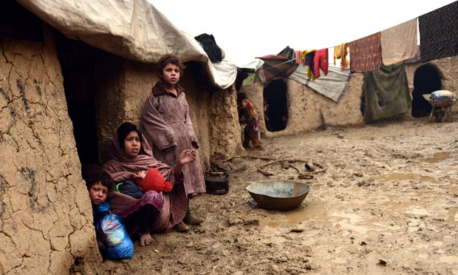 | 3.  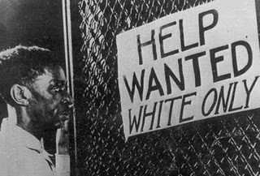
4. | 5. | 6.

a) Drugs b) Pollution c) Discrimination d) Animal Abuse e) Violence a) Poverty
Part II Grammar
Present Perfect

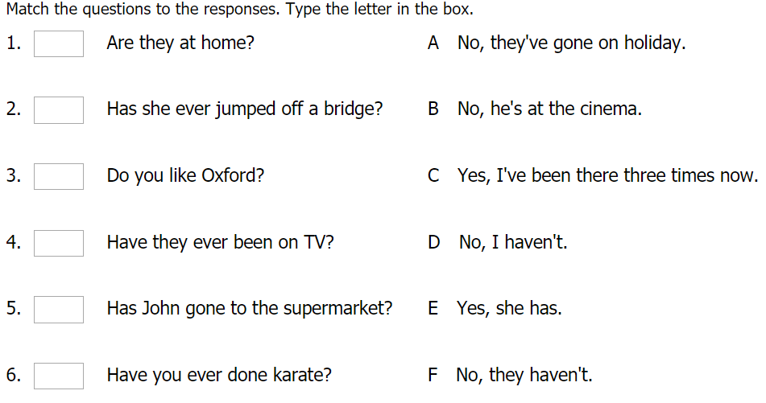
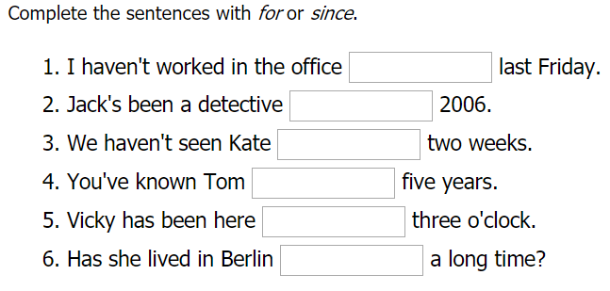

Une

