Worksheet 2
3rd Grade
Nombre: ____________________________________________________________________
Ideal Score: 15 pts. Obtained Score: _________ Mark: _____________

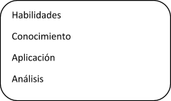
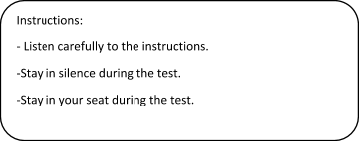

Item I: Jobs

Look at the picture and choose the correct alternative (3 points)
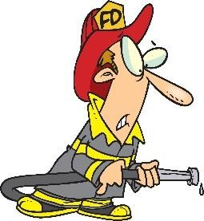

a. Teacher | a. nurse |  | a. police oﬃcer
b. Astronaut | b. Fireﬁghter |  | b. chef
c. Waiter | c. dentist |  | c. doctor
Item II: Numbers
Match the writing to the numbers (5 points)
A) THIRTY ONE |  | 10
B) TEN |  | 18
C) TWO |  | 2
D) EIGHTEEN |  | 31
E) TWENTY SEVEN |  | 27

28/2/2019 3 básico - Documentos de Google

Item III: Animals

Match the animal and its name. See the example! (7 Points)
