**Worksheet N°2**

Name: _______________________________________________________________

Objective:

- Demostrar uso del lenguaje relacionado a funciones del lenguaje para hablar en pasado y sobre trabajos

Skills

- Aplicar

- Reconocer

Instructions:

a) Use a blue or black pen, no corrections, readable handwriting

b) **Do not use translator, use an online dictionary** <https://www.wordreference.com/>

**c)** Use online conjugator <https://www.wordhippo.com/>

**Part I Vocabulary**

**Match[1]** the correct job with the corresponding **image**

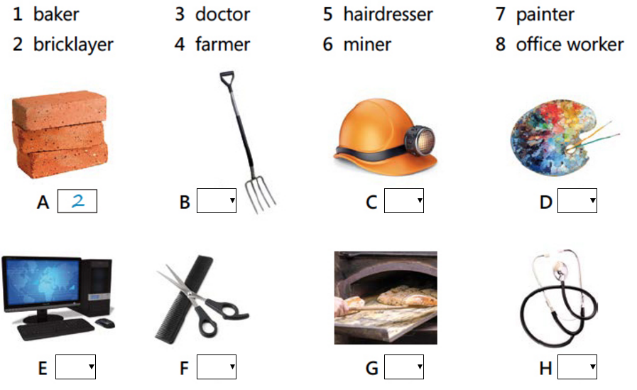

**Part II Reading**

**Jobs**

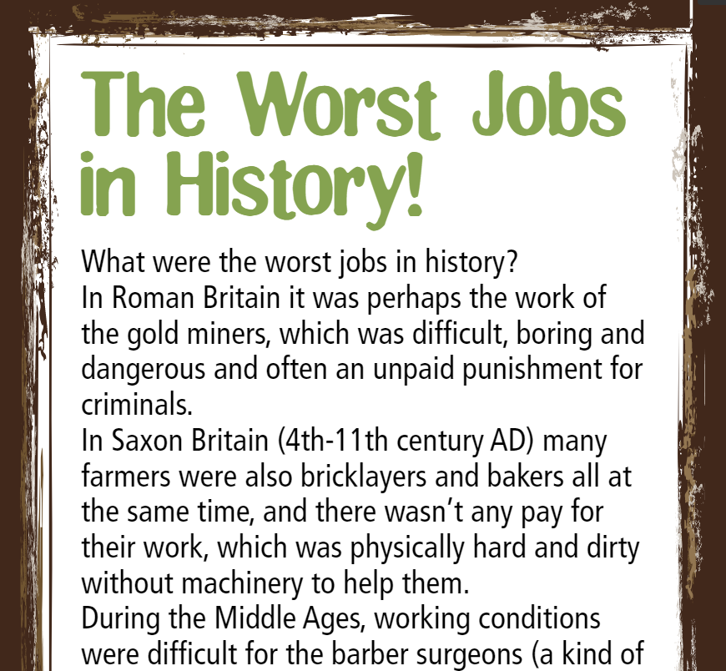

**Create you personal glossary with difficult words**

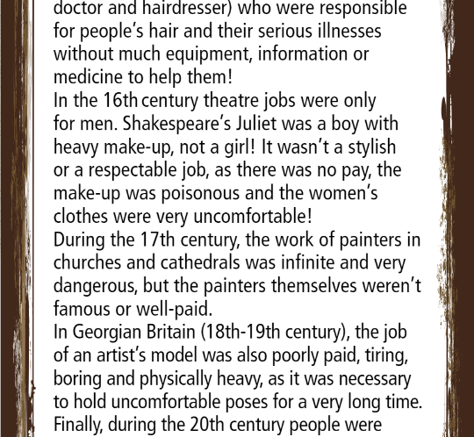

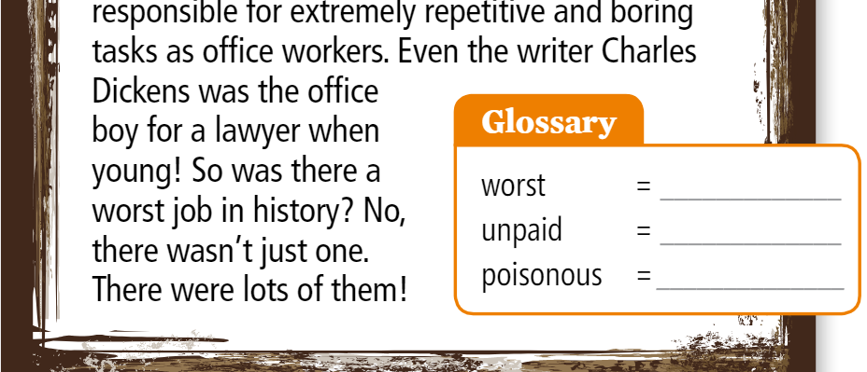

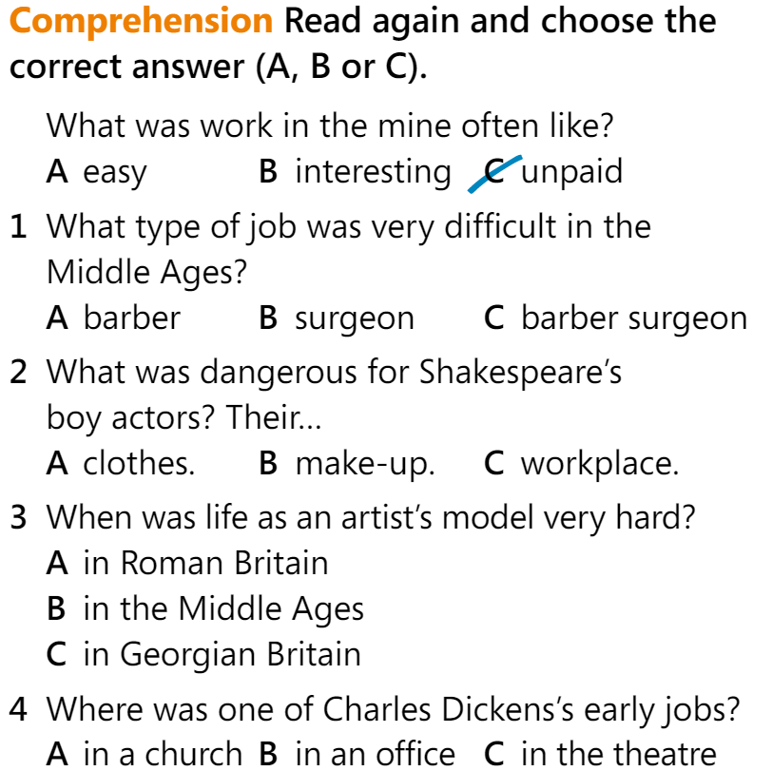

1. Une