**Worksheet N°3**

Name: _______________________________________________________________

Objective:

- Comprender ideas generales y específicas en textos adaptados relacionados a trabajos

Skills

- Aplicar

- Reconocer

Instructions:

a) Use a blue or black pen, no corrections, readable handwriting

b) **Do not use translator, use an online dictionary** <https://www.wordreference.com/>

**c)** Use online conjugator <https://www.wordhippo.com/>

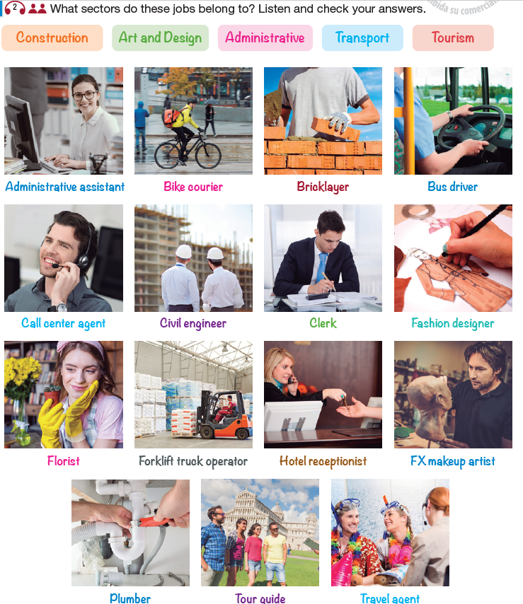

Click [**here**](https://drive.google.com/file/d/1UUb6gsrZ1RL0CZF34yDe0GkEA6rAuzxw/view?usp=sharing)for the audio

**Reading**

