Worksheet N°2

4th grade

Name: ____________________________________________________________________

Ideal Score: 15 pts. Obtained Score: _________ Mark: _____________

Objectives:

- Consolidar contenidos relacionados a las partes de la casa visto el año pasado.

Important!

b) You **CAN** use your dictionary

c) Good luck!!!

Skills

- Identificar

- Aplicar

- Reconocer

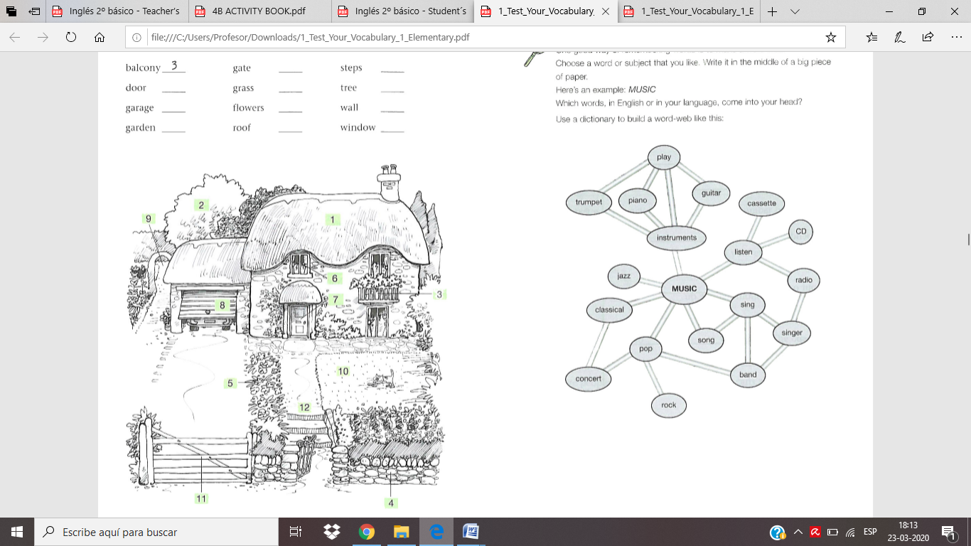Read and number. Use dictionary.