Worksheet N°3
Name: _______________________________________________________________
Objective:
- Demostrar uso del lenguaje relacionado a funciones del lenguaje básicas

Skills
- Aplicar
- Reconocer

Instructions:
a) Use a blue or black pen, no corrections, readable handwriting
b) Do not use translator, use an online dictionary https://www.wordreference.com/
c) Use online conjugator https://www.wordhippo.com/

The verb to be can be translated as ser o estar in Spanish. It is used with adjectives to describe people or objects. It is one of the most irregular verbs and the most used
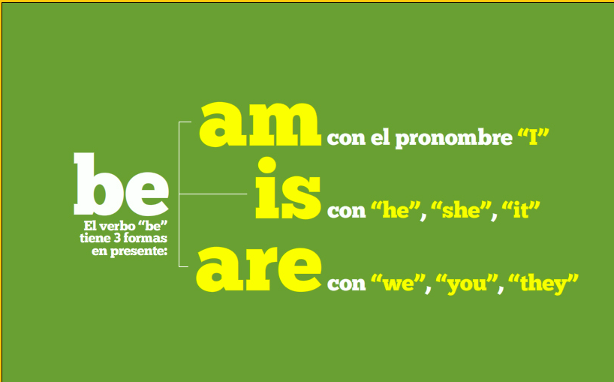

Personal pronouns replace the name of people or objects:
I = yo | You = tú. | He = él | She = ella
We = Nosotros | They = ellos | It se usa para un objeto y animal | You: usted, vosotros, ustedes.
In english, it is not posible to identify a form for usted, we use you.

Excercises:

be: affirmative long and short forms
Choose the correct answer.

- Hi, I Otto.
- in England.
- John my friend.
- New York in the USA.
- from Germany.
- Tom and Sue in the classroom.

Be: negative forms

Make the sentences negative. Type the words in the box.

- I'm in the classroom.
- Joe and Mel are here.
- You're from Spain.
- He's my teacher.
- We're 12.
- Paris is in Japan.

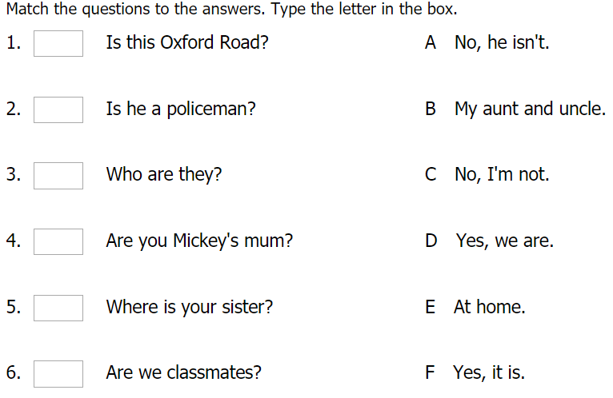

Traducido

