Worksheet N°1
6th grade

Name: ____________________________________________________________________
Ideal Score: 15 pts. Obtained Score: _________ Mark: _____________
Objectives:
- Consolidar contenidos estudiados el año anterior relacionados con presente simple y vocabulario sobre comida.

Instructions:
a) Use a blue or black pen, no corrections, readable handwriting
b) You CAN use your dictionary
c) Good luck!!!

Skills
- Identificar
- Aplicar
- Reconocer

- Present simple:
- Complete with the correct form of the verb (affirmative sentences).

- Andy ___________(wash) the family car.
- Every morning my mother ___________ (wake up) at 6 o'clock.
- Mr. Black ___________(check) e-mails in the evenings.
- The girls ___________(go) the shopping.
- Mandy and Susan ___________(watch) films every weekend.
- I __________(meet) my friends at school.
- John often ___________(play) handball.
- It ___________(to be) a beautiful day today.

- Transform into negative sentence using don’t or doesn’t.
- Kevin plays basketball. _____________________________________________
- Steve can make breakfast. ______________________________________ ____
- I run to school. ______________________________________ _____________
- The kite flies into the air. ______________________________________ _____
- He is from Spain. __________________________________________________
- Mr Smith teaches French. ______________________________________ _____
- Sandy washes her hair. ______________________________________ _______
- The children know the answer. ______________________________________ _

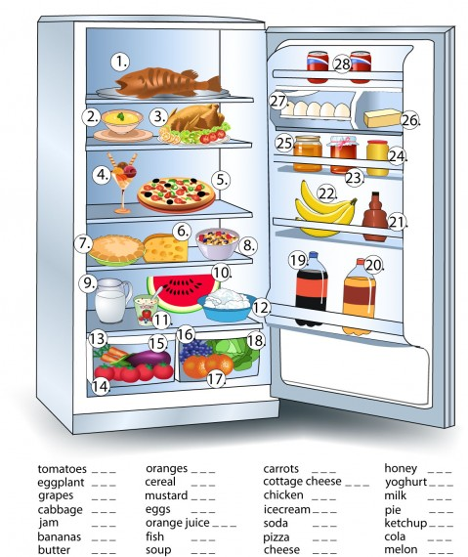
- Write the correct number to each Word.

